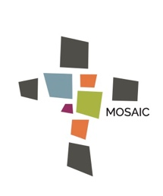
Sermon-based Discussion Questions
Whether during the message or sometime later in reflection, please answer the following questions and be prepared to discuss responses with others at your next TABLE gathering.
- Speaker: ___________________________________________________________
- Series: _____________________________________________________________
- Title or Topic: _______________________________________________________
- Date: ______________________________________________________________

1. What would you say is the big idea or main point of the message?
2. What biblical knowledge and/or spiritual insight did you gain from what was
discussed?
3. How did the Holy Spirit speak to you personally, challenge you practically or inspire you to grow in your walk with Jesus and/or with others via the message?
4. Are you confused by anything that was said or did you leave with a question as of yet unanswered?
5. Is there any aspect of the message that you would like further to discuss?
6. Is there for you a key takeaway and, if so, what is it?

