A Disruptive Approach¹
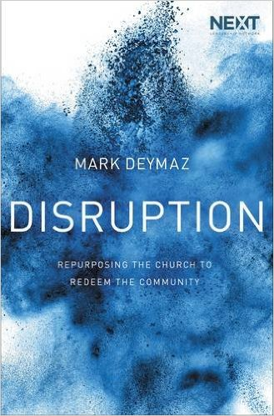
After winning the 2012 Super Bowl as head coach of the National Football League’s (NFL) New York Giants, Tom Coughlin provided insight on what it took for his team to return from an ambiguous 7–7 start to finish the season 9–7 and then go on to win the rest of their games to become the league’s champion. Coughlin said, “Offense, defense and special teams doing their job. Each group having different objectives and motives but playing in harmony for each other, for the good of everyone.”
Let’s break this down.
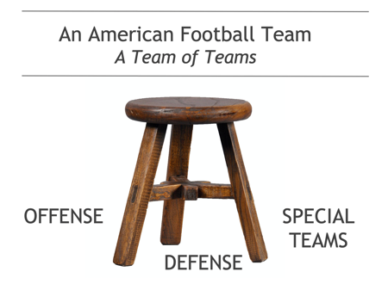
A football team is actually composed of three separate teams, or groups, as Coughlin calls them: offense, defense, and special teams. While the entire team has a head coach, each separate group also has a coach of its own. For the entire team to win a big game, such as an NFL Super Bowl or, on the collegiate level, a National Championship, each separate group must perform with excellence and minimize mistakes. For example, on any given day a team’s offense may play well, but the game will likely be lost if its defense can’t stop the run. Similarly, its offense and defense may play well for nearly sixty minutes, but a game will be lost in the final seconds of play if a late kickoff is returned for a touchdown or a field goal is missed by a kicker. In such cases, the special teams group fails and the entire football team loses the game.
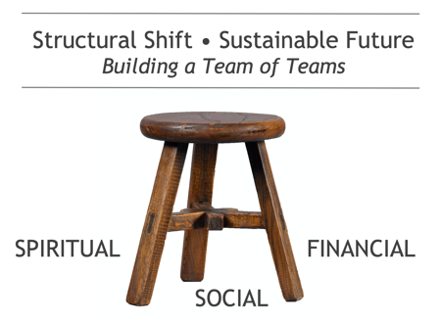
Similarly, a well-balanced approach is needed today in the local church to advance a credible, compelling, and sustained witness of the gospel in an increasingly diverse, painfully polarized, and cynical society... a disruptive model for church growth and development in the twenty-first century.
As with a football team, think of your local church as one team composed of three separate teams, each group having different objectives and motives but playing in harmony for each other, for the good of everyone. The three teams can be designated spiritual, social, and financial.
Assuming your church is structured this way, consider the various ways that each team might secure or generate revenue by creating multiple streams of income.

- The Spiritual Team exists to evangelize, baptize, disciple, and multiply the Christian faith.
  - It gathers people for worship, connects them relationally, and deploys them to work with children, with young adults, overseas as missionaries, and in many more ways, according to their varying passions and giftings.
  - The Spiritual Team (the church itself ) is organized as a nonprofit and therefore able to receive tax-deductible donations, more specifically tithes and offerings.
- The Social Team exists to advance compassion and justice in the community.
  - It distributes food and clothing to those in need, mentors at-risk children, provides low-cost legal services to immigrants, assists families who have adopted or foster children, works with teen mothers of preschoolers, and teaches English as a second language (ESL), and the like.
  - The Social Team is organized by the church as a separate nonprofit (think two sisters living in the same house). It is therefore able to receive local, state, and federal grants not otherwise available to churches; engage and solicit resources from other churches or Christian organizations not typically inclined to give money directly to a local church; and tax-deductible donations from individuals.
- The Financial Team exists to encourage and develop small business and generate sustainable income.
  - It leverages church assets, including property or facilities, money, and people, to revitalize abandoned space, create jobs, establish rent roles, reduce the likelihood of crime, generate taxes for the city, and advance the common good.
  - The Financial Team is organized as a for-profit entity (or entities) and therefore not able to receive tax-deductible donations. Income is generated via ROI and/or entrepreneurial business enterprise.

¹The following article is aggregated from the book, Disruption: Repurposing the Church to Redeem the Community by Mark DeYmaz (Thomas Nelson/Leadership Network, March 7, 2017). Permission is given for distribution and/or reprinting only if properly sourced and attributed via ©Mark DeYmaz.

